INDIAN INSTITUTE OF TECHNOLOGY MANDI

HIMACHAL PRADESH 175005

HS105_2

BASIC COMMUNICATION SKILLS

LANGUAGE, COMMUNICATION AND THE INTERNET

Written by:

Aashima, b17031

Jhalak Choudhary, b17046

Namrata Malkani, b17096

2020

# Acknowledgements

We wish to thank the course instructor Dr Aruna Bommareddi for her guidance throughout the course of this project.

Disclaimer

The following report contains some very offensive expletives. The objective is not to hurt any sentiments or be biased in favour of or against any particular person, society, gender, creed, nation or religion. Our only motive is to understand, analyse and research the words’ usage for the purpose of our case studies on communication through English language over the Internet. We do not support or promote their usage by any means.

Contents

Introduction. 5

Chapter 1. 6-9

Chapter 2. 10-21

Chapter 3. 22-34

Conclusion. 35

Glossary. 36-41

References. 42-43

Introduction

The English language is undergoing a gradual change ever since the advent of the Internet. It has not only enriched the language with new words but also given new meaning and context to old vocabulary. Everything about the language – words, meanings, spellings, sentence structure, punctuations, has experienced a change in this age of the Internet. The report discusses how technology has changed the way we communicate and how various social platforms have contributed to this change. It contains inline examples of the changes in English language for communication over the internet. For greater understanding, it also contains analysis of conversation snippets over different platforms. It concludes with a list of words born or reborn on the internet.

With the rapid invention and adoption of new technology, the medium of communication has dramatically changed – especially in recent years. Internet modalities have largely replaced paper and earlier wire-based communications. Internet communications continue to evolve in ways that its founders could never imagine or envision.

The biggest impact of technology on communication is the speed of the internet and the possibility of sending emails and chatting. Before our current level of technology, a document often required retyping on the typewriter before the final version. Sending the letter to someone else required a visit to the post office and a postage stamp. But now, we can send multiple messages to someone without giving a second thought about correct grammar or spellings. Computers and the Internet have made the process of creating and editing documents, using spell check and grammar automatic and easy. Emails let us send the documents to any part of the globe within seconds, making letters mostly useless. The internet has increased the speed and reduced the costs drastically.

Now it is so easy to take our phones with us, just slip it in our pockets and use it where ever. We can communicate wherever we go without a hassle. Now we can talk to multiple people at once. We can communicate across long distances to large groups of people almost instantaneously with international conference calls and webinars. We can make a group chat instead of individually contacting multiple people. It makes planning for parties and other gatherings easier. It makes academic collaborations easier and efficient.

The internet has given us many other ways of conveying text. We can send emoticons, pictures, animations and many other different ways to talk. Now instead of just writing we can do all these other things. We can replace a word with symbols which makes things even faster. We used to be only limited to writing letters and using the type writer but now we have it way easier. We can text, call, go on apps like Facebook, Instagram, snapchat and many other social media handles to communicate. We can post photos and update statuses.

Chapter 1

The Beginning

Although the internet came into existence in the second half of the twentieth century, its influence on language began to escalate only in the 1990s. It has drastically changed the way people communicate and use English, both in writing and speaking. Consequently, the world has become increasingly interconnected through synchronous and asynchronous mediums, such as SMS, online chat, Yahoo messengers, email, blogs and wikis. The arrival of applications such as Facebook, Twitter, Skype, WhatsApp and Viber brought more changes to the language. The Internet has given rise to what is arguably a new variety of English that differs from standard varieties. This chapter looks into the history of various social platforms and gives few examples of how communication over these platforms has changed the English language. The discussion is taken forward in form of case studies in later chapters.

* 1. Evolution of social platforms

1.1.1 Brief History of the Internet

The Internet started in the 1960s as a way for government researchers to share information. Computer in the 60s were large and immobile and in order to make use of information stored in any one computer, one had to either travel to the site of the computer or have magnetic tapes sent through the conventional postal system. Another catalyst in the formation of the Internet was the heating up of Cold war. ARPANET (Advanced Research Projects Agency Network) was formed; it eventually evolved into what we now call the Internet. ARPANET was a great success but membership was limited to certain academic and research organizations who had contracts with the Defence Department. In response to his, other networks were created to provide information sharing.

January 1, 1983 is considered the official birthday of the Internet. Prior to this, the various computer networks did not have a standard way to communicate with each other. New communication protocols were established. This allowed different kinds of computers to “talk” to each other. All networks could now be connected by a universal language.

1.1.2 Timeline of social platforms

Human beings are social creatures, we thrive on, and in fact need social interactions to maintain a healthy life and mind. Social media taps into these primal needs and it should come as no surprise that social media sites and apps are so popular today. Social media channels have been everywhere since the early 2000s and have been growing exponentially. Let’s look at the timeline of social media.

1. The Beginning (1844) – Samuel Morse made the first step towards some resemblance of social media when he sent a telegraph from Washington D.C to Baltimore. Morse’s first message read “What Have God Wrought?”.
2. Military’s first social media attempt (1969) – ARPAN (Advanced Research Projects Agency Network) wanted to connect Universities on a proto-internet. It worked great, if transmitting two letters was the goal. Unfortunately, ‘LO’ weren’t the complete ‘LOGIN’ that they had planned to send over.
3. The first social media is born (1997) – *Six Degrees* allowed users to set up a profile page, create lists of connections, and send messages within networks. It had a peak of 1 million followers from 1997-2001.
4. (1999) – *LiveJournal* was a platform where users could blog as a form of keeping friends updated with their lives.
5. *Hot or not* (2000) – The site allowed users to submit photos of themselves so others could rate their attractiveness.
6. *Friendster* (2002) – It was originally going to be a dating site that would help set up people with friends in common. Users could create a profile, include “status updates” and reveal their mood. Messaging “friends of friends of friends” was also a thing
7. *Myspace* (2003) – Its customizable public profiles were visible to anyone, and were a welcome contrast to Friendster’s private profile which were available only to registered users.
8. (2003 - 2005) – *Facemash* was launched in 2003. *The Facebook* followed in 2004 and became *Facebook* in 2005. It is an online social media and social networking service. *LinkedIn* emerged and targeted its business community. It gave users a place to post their resume and privately message people with a business-oriented mind. Photo sharing sites like *Photobucket* and *Flickr,* and blogging platform *WordPress* also came into existence. *Gmail* was launched in 2004. It is a free email service developed by Google. *YouTube* was launched in 2005. It is an online video-sharing platform. *Reddit* also arrived that year. It is a social news aggregation, web content rating, and discussion website.
9. (2006) – *Twitter* and *Facebook* truly took flight in 2006. *Twitter* is a microblogging and social networking service on which users post and interact with messages known as “tweets”.
10. *Tumblr* (2007) – The microblogging site allowed users to curate pictures, videos and text and “reblog” their friends on their “tumblelogs”.
11. *Weibo* (2009) – It is a Facebook and Twitter hybrid.
12. *Grinder* (2009) – First geosocial networking app for dating geared towards gay and bisexual mean.
13. *WhatsApp* (2009) – It is a freeware and cross-platform messaging and VoIP service. It allows the sending of text messages and voice calls, as well as video calls, images and other media, documents and user location.
14. *Instagram* (2010) – It is a photo and video-sharing social networking service owned by *Facebook*.
15. *Pinterest* (2010) – It is an image sharing and social media service designed to enable saving and discovery of information. It allows users to share images associated with project, goods and services, and to visually discover new interests by browsing images others have posted.
16. *Snapchat* (2011) – It is an image messaging app that lets users exchange pictures and videos (called “snaps”) that are meant to disappear after they’ve viewed.
17. *Slack* (2015) – It is a business communication platform which is designed to replace email as the primary method of communication and sharing.
18. *Discord* (2015) – It is a freeware VoIP application and digital distribution platform designed for creating communities ranging from gamers to education and businesses. It specialises in text, image, image, video and audio communication between users in a chat channel.
    1. The internet is changing the English language

For more than 600 years, English speakers used *because* as a conjunction meaning “for the reason that”, dutifully following it with a full clause of explanation. Then, a few years ago, this old standby suddenly began bursting with new life, as people started using it to form terse, cheeky rationales in a manner that defied all grammatical decorum:

1. “How do you know climate change is real?”
2. “Because science.”
3. “Why are you sleepy?”
4. “Because burrito.”

Language has undergone metamorphosis – evolution made possible by the ascendance of the web and the unprecedented explosion of informal writing that has come with it. Billions of people have become authors and found ways to type out the flirtations (😘) and frustrations (aklefj;awkjfdsafjka!!!) that for centuries existed only as informal speech.

The formal, unemotional writing we are all taught in the classroom simply won’t do in places designed for virtual mingling. We’ve also managed to use keyboards to restore the dynamism of face-to-face interaction.

1. We tap all caps when we feel LIKE SHOUTING
2. We use the abbreviation *lol* not just to mean “laugh out loud” but also to diffuse slightly awkward situations or to offer empathy
3. We lengthen words to show just how much we feeeeeeel
   1. Brand new dialects for online communities

Different people from different places might speak with a different accent or dialect. But are there Internet dialects? We can probably all agree with the fact that some aspects of Internet language have become widespread that they’re recognizable by the masses, including people who aren’t super tech-friendly. Basic emoji, for example, are often used in advertisements and on TV, as are abbreviations like “brb” or “lol”, which have made their way into texting and casual emails. But there are also whole communities inside the Internet – and given that communities often share the same accents and dialects, these online communities may have their own version of a dialect. Users who have been active participants in these online communities have developed a certain “lingo” that is common sens to them, but is unfamiliar to the rest.

1.3.1 Tumblr

A lot of people joke about “Tumblr speak”, referring to the way *Tumblr* users frequently “speak” in a similar fashion. There are text-based posts consisting of run-ion thoughts or sentences without correct capitalization or punctuation. Of all online communities, *Tumblr* is possibly the one that has gone furthest towards having its own dialect that is incomprehensible to outsiders. There are online guides into “how to speak Tumblr”. Here’s a Tumblr paragraph.

I CANT EVEN what is this life ruiner. Having ALL THE FEELS akdfhakdghsgds what is air

The writer is extremely excited by someone. What’s fascinating about this is that none of the phrases above are borrowed from other dialects, except perhaps the keyboard smash – akdfhakdghsgds – but that can denote anger elsewhere, while on Tumblr it usually means wild, flailing excitement.

1.3.2 Lolcatz

We’re learning new grammar rather than losing our ability to speak English. How do cats and dogs speak? A toddler will give the conventional answer along the line

“cats go miaow, dogs go woof”

However, an internet user on *Lolcatz*, will say that cats and dogs are

“in ur article and speakz lyk dis.”

“much words, very English, so article. Wow.”

The thing about writing these so that they sound ‘correct’ within the rules of the “meme” is that it takes a reasonably advanced knowledge of English spelling and grammar. Both are deliberately incorrect along different lines, and a person can’t be deliberately incorrect unless they know already know what the correct formulation is. *Lolcatz* uses old-school internet abbreviations and misspellings such as “ur” for “your”, replace “s” with “z” and confuse third-person singular with the first-person singular – “I has” in place of “I have”.

1.3.3 Others

Tumblr’s dialect is among the most distinctive, but it’s not the only online dialect. There’s the snippy, to-the-point use of language on *Twitter*, because of character limit. The popular “hashtag” may be exciting for active users but not for someone who does not use *Twitter.*

*Reddit* also has its own vocabulary; abbreviations still exist there despite being gone from rest of the internet. Its users tell each other:

1. TL;DR (too long; didn’t read)
2. TIL (today I learned)
3. FTFY (fixed that up for you)

Chapter 2

Analysis of the language of communication over the Internet

The following chapter discusses some of the conversations people have on various social media and networking platforms on the Internet, and presents a brief analysis in the context of various transformations, in existing, as well as new semantics, grammar and pragmatics of the English language. Screenshots of conversations from three social media have been taken, namely LinkedIn, Slack and Discord.

*Section 2.1* has subsections devoted to each of the platforms, explaining briefly about the general nature of communication taking place here, the platform’s broad effect on the evolution of English language, followed by the conversations’ screenshots. *Section 2.2* presents studies on the conversations, in various areas.

2.1 Platforms for communication via the Internet

2.1.1 LinkedIn

*LinkedIn* is an American business and employment-oriented online service, mainly used for professional networking. Hence, most of the communication taking place is direct, of sales and business-oriented nature.

*Figure 2.1* and *figure 2.2* show two communications taking place on this website. The first one takes place between a sales employee of MongoDB Inc., and a tech Intern at Adobe Inc. A feature of LinkedIn is that marketing teams can send direct sponsored texts to thousands of people in relevant demographics. The second one is a sponsored direct message from a marketing manager at JetBrains.

2.1.2 Slack

*Slack* is a proprietary business communication platform that offers many IRC-style (discussed later in *section 2.1.3*) features, including persistent chat rooms (channels) organized by topic, private groups, and direct messaging. Most of the communication is technical, academically oriented, professional or informal depending on the group, but mostly informative.

*Figure 2.3* shows work related and certain informal discussions via direct messages between an intern at a multinational tech company and her mentor. *Figure 2.4* shows a group conversation on the same company channel as previous, but this time an engineering team’s discussion. While *figure 2.5* shows the discussion amongst a group of students working together on a technical project in a university course, certainly more informal than the one shown in *figure 2.4* .

**2.1.3 IRC – an expiring platform in the modern era**

IRC ([Internet Relay Chat](http://en.wikipedia.org/wiki/Internet_Relay_Chat)) has been around since 1988, which makes it ancient in Internet terms. Since then it served as an invaluable way of communicating for scores of users around the world. For almost whatever one would like to discuss or get help with, there had been an IRC network and channel that would serve their interests.

But since the arrival of the new century, IRC has dropped in popularity, with users moving to other forms of communication like the web and social media. The way it affected the written English language was akin to Slack, its ad hoc successor, which has been discussed in the chapter in detail, by the means of its example conversations.

**2.1.4 Discord**

Discord, a real-time chat platform founded four years ago as a way to make it easier for gamers to communicate has outgrown its origin story and become the default place where influencers, internet creators and anyone with an audience can connect with their community. Visually, Discord is very similar to Slack. A user can join different servers, each server functions as its own community. Within a server, you can hop between a long list of hashtag-marked channels, some of which are text-based, and some are group voice chats.

Despite being very new in the game, compared to its other social media counterparts, discord has had a very moving effect on the modern English language, already boasts of a quarter billion users, a majority of them being teenagers joining servers of their favourite YouTube, Instagram content creator, in hopes of ‘blending’ in the community and getting noticed by the server host.

***Figure 2.6***, ***Figure 2.7*** and ***Figure 2.8*** are from a server called “f r e s h”, run by the creator of a popular YouTube channel of the same name. The channel mainly creates videos based on Reddit posts, another popular mainstream community platform on the Internet. The conversations in these figures, despite being in a language known to an outsider to the community, would strike as mostly incomprehensible to that person, even if given in full context. This just goes on to show that the social platform that has allowed exclusive communities to thrive, has changed the language to such an extent that the same English would rather appear to a non-member, as an unknown dialect, with its own semantics and pragmatics, built on the base of the original language.

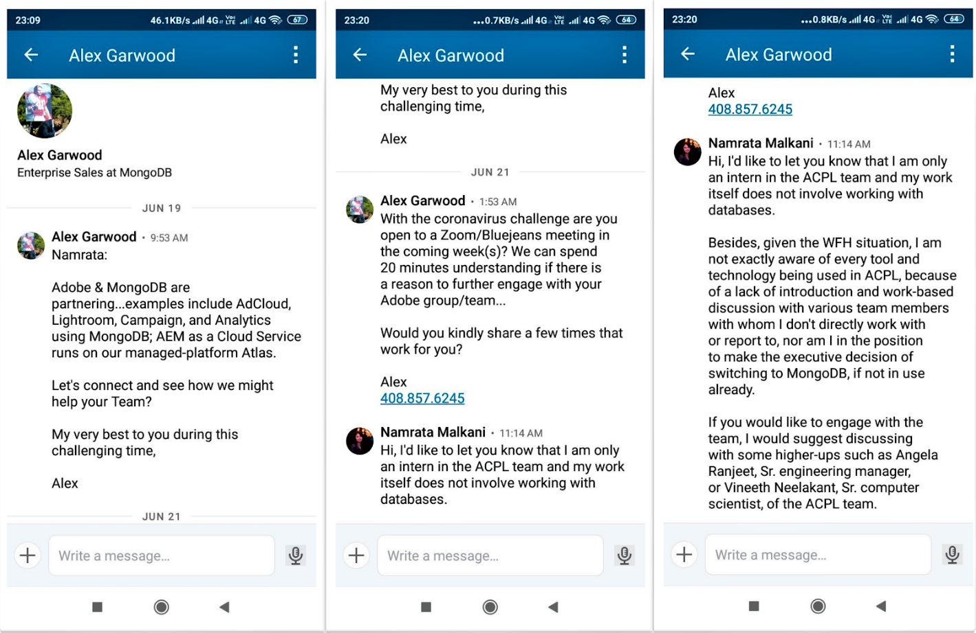

*Figure 2.1*

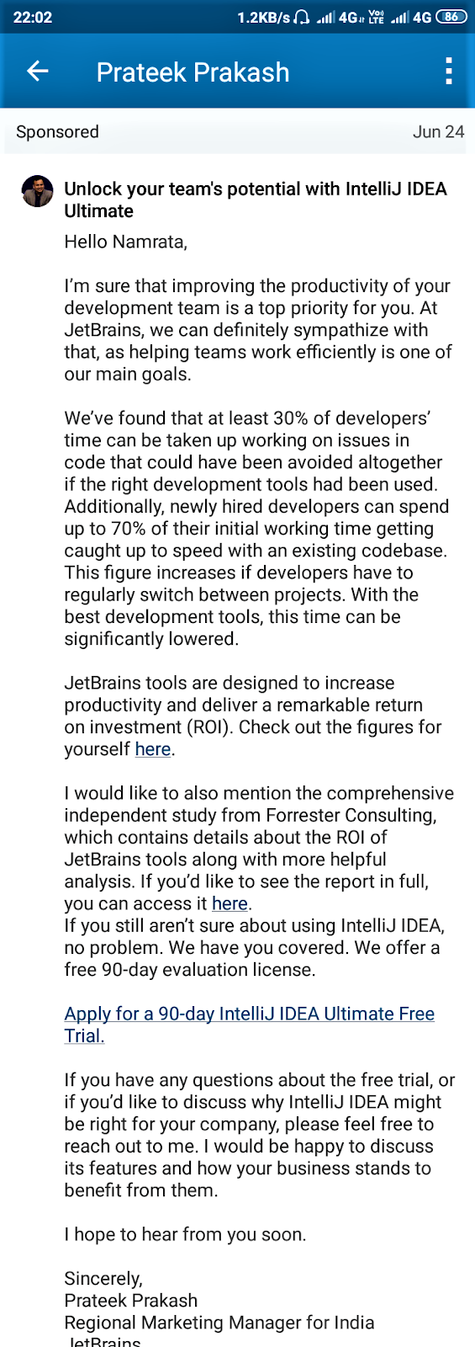

*Figure 2.2*

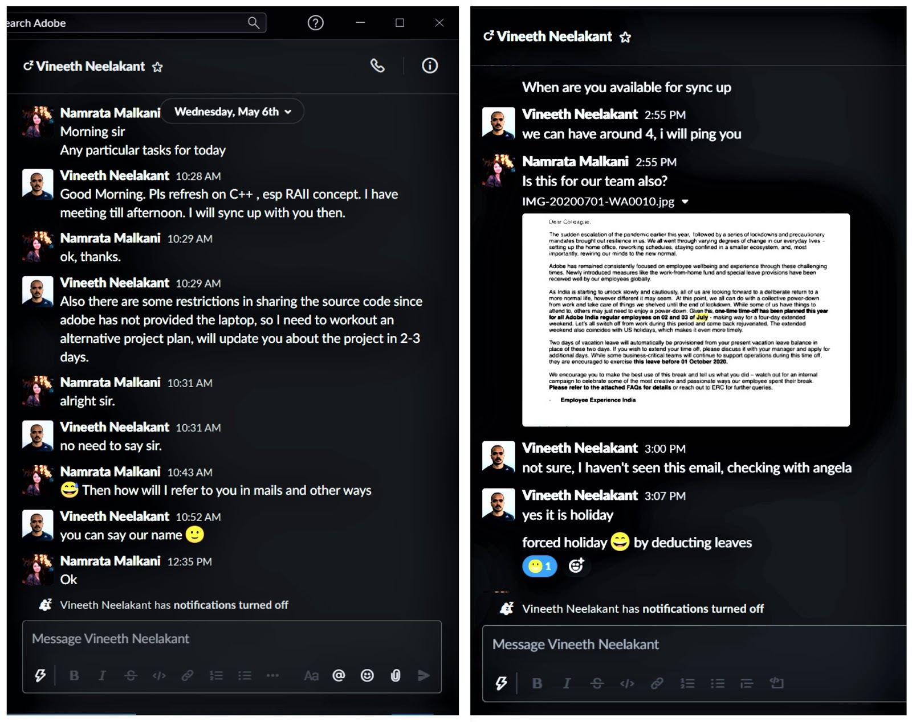

*Figure 2.3*

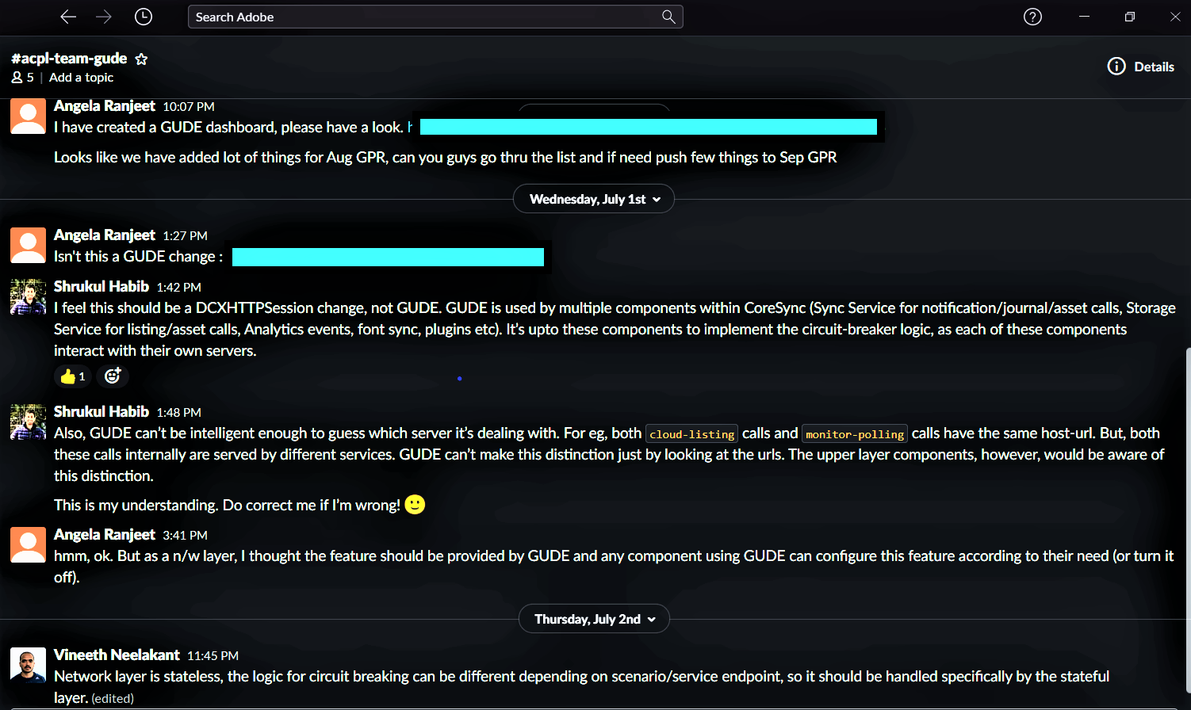

*Figure 2.4*

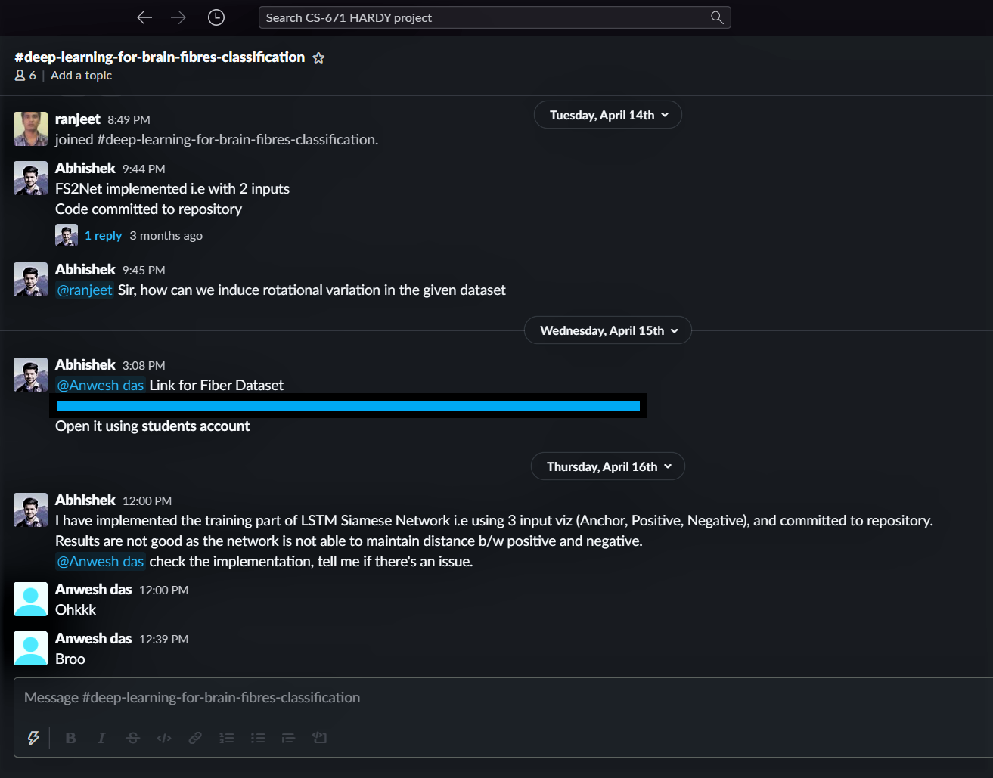

*Figure 2.5*

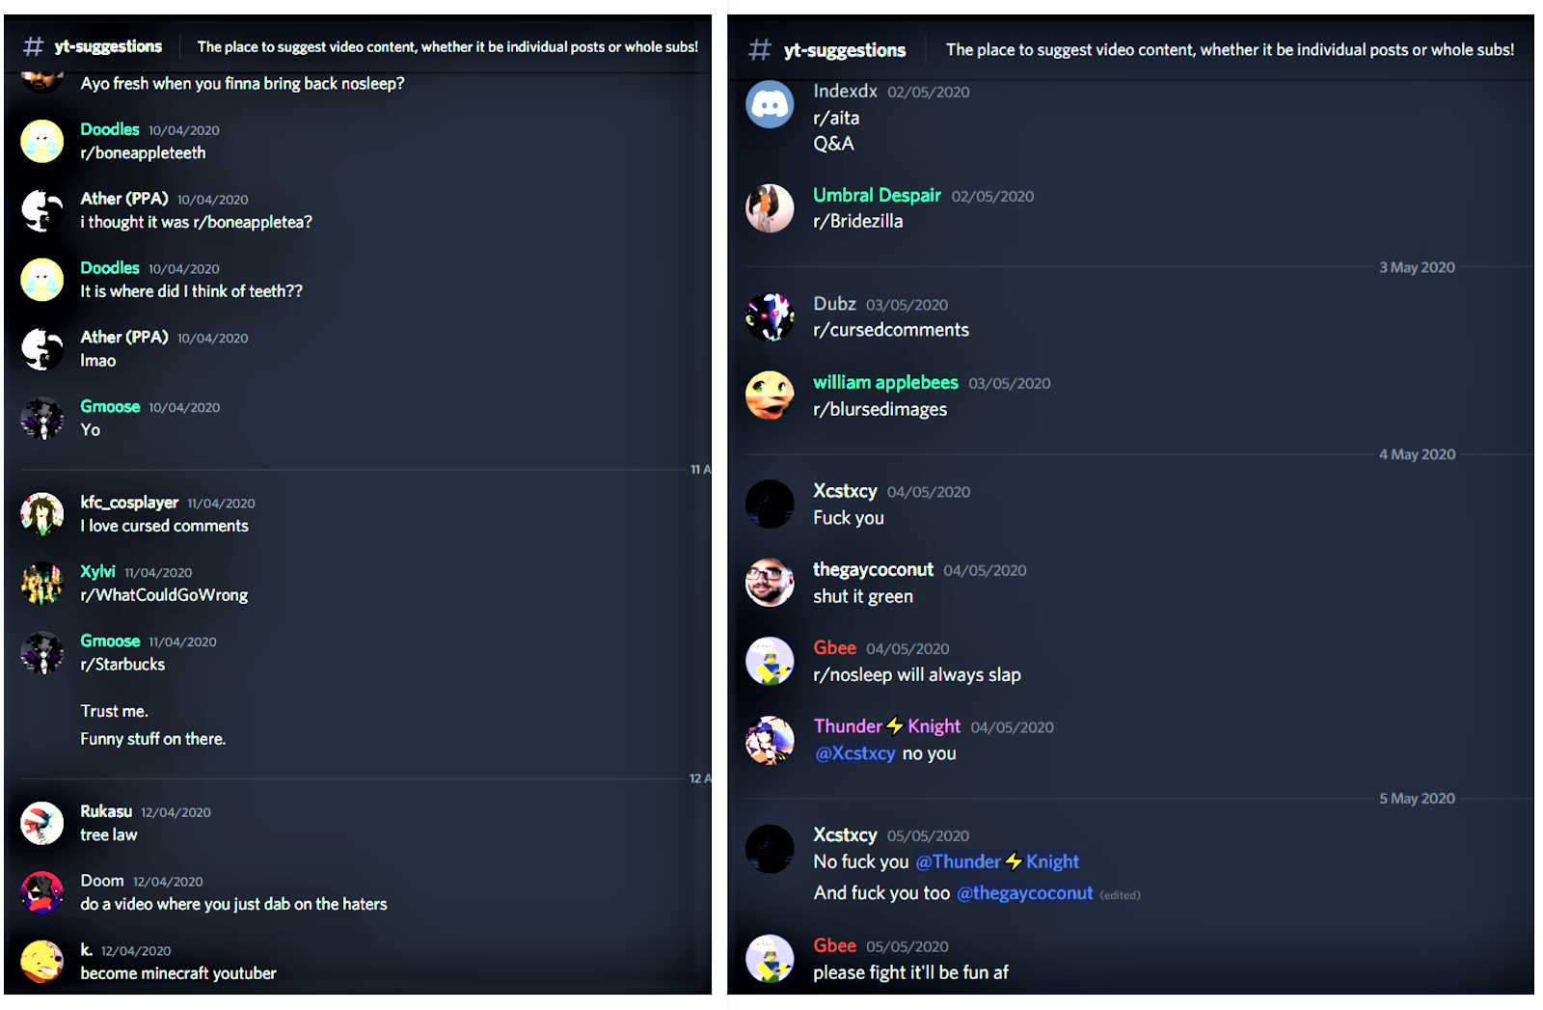

*Figure 2.6*

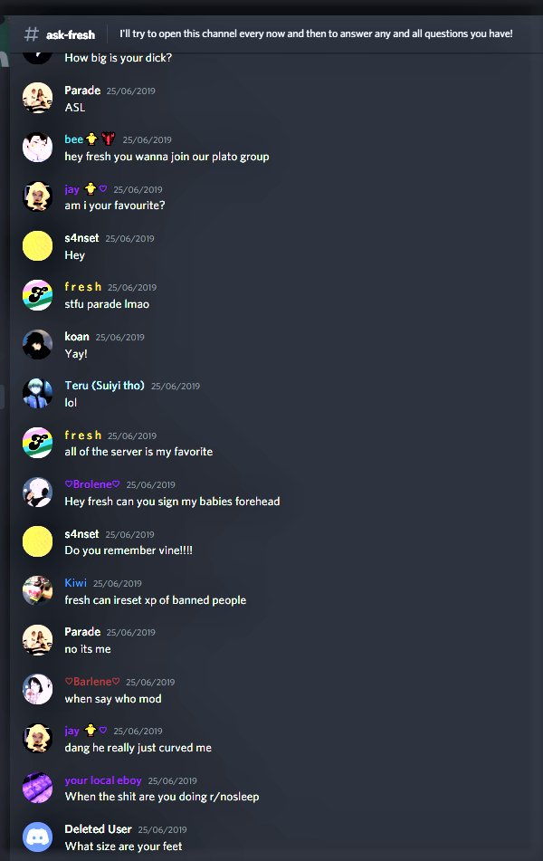

*Figure 2.7*

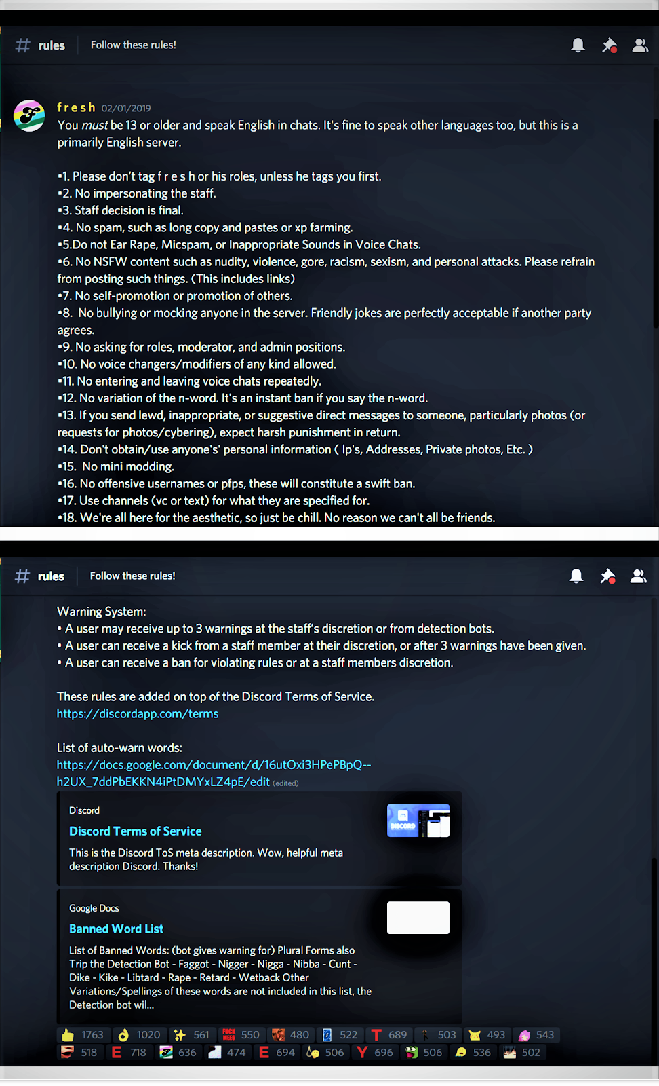

*Figure 2.8*

2.2 Areas of Analysis

Broadly classified in these seven subsections, we analyse how the English language is undergoing transformation, by the means of communication over the Internet.

2.2.1 Interpersonal Relations and Expression of Emotions

With the availability of various chat platforms and a multitude of emoticons that they have to offer, the relay of feelings has become tougher and easier at the same time. While one can express approval 🙂, despair 😞, humility/confusion 😅, in much less words, in fact no words at all, at the same time it is very easy to slip and give the wrong idea! A good example of both kinds can be found in *figure 2.3*. In the first screenshot of the figure, use of 🙂, 😅, while not completely necessary, do add to the aesthetics of the conversation and help ease the communication gap between a new mentor and mentee. This kind of modification of language that allows to convey facial expressions, is particularly useful in scenarios where face to face interaction is difficult to take place, especially when the relation is new and people have no idea about each other’s attitude, likes and dislikes. In the second screenshot of the same figure, another use of emoticons is seen but in a contrasting way, a rather disapproving sentence with a happy face 😄! It becomes unclear if the person is so angry, they end up angry laughing, or is it a disgruntled laugh or even a mistakenly conveyed expression.

*Slack*, as a collaboration platform does help one accentuate the non-verbal or body language-based communication even in written correspondence. One way is the discussed use of emoticons in the sentences, another is allowing one to ‘react’ to text blocks using these very emoticons. In *figure 2.4*, a 👍 is given by Angela, Shrukul’s manager, to his text which is explaining something to her. Shrukul, being the cordial junior he is, also uses 🙂 when saying he is open to suggestions, to signify genuineness, in his second text continuing his explanation. While we can communicate information pretty much the same without these emoticons, these small circles do go a long way, forging strong interpersonal relations and add a sense of feeling to our relay of data.

2.2.2 Technical Jargon

A large part of communication over media like *LinkedIn* and *Slack* involves usage of words, acronyms, short forms which are related to work and academics, especially when the field of job involved is Information Technology (As is, in the *LinkedIn* and *Slack* conversations in this chapter). The modern technical jargon is similar to slang, in that it can be unique to a group and unintelligible to outsiders. While certain words and terms can be widely known in the scientific or IT community as a whole, but still incomprehensible to people not knowledgeable of these fields as can be seen in *figure 2.1, 2.2* and *2.5*, certain words, corresponding to technology developed within and limited to only a particular engineering team, are not understandable to even those who work same (large) corporate but are not a part of team, as seen in *figure 2.4* .

*Figure 2.1* serves as an example of text with words and abbreviations which can be common knowledge to many people such as ‘MongoDB’, ‘AEM’ (Adobe Experience Manager) and terms which are organization specific, but used in a context that knowing the exact meaning of it is isn’t important to the reader of message, to be able to understand the conversations, such as ‘ACPL Team’ (Adobe Content Platform Local).

*Figure 2.5* shows usage of words and phrases which might be incomprehensible to even someone involved in the IT industry, but not so exclusive that only the members of that particular channel will understand, if shown the texts. It basically makes sense to people who specialize in a small area of computer science development called ‘Deep Learning’. Hence these terms can be and not be exclusivist at the same time, depending on the demographics considered.

Another peculiarity of technical jargon in modern English is the way in which it can put us in the state of knowing and not knowing at the same time. *Figure 2.4* shows repeated use of the abbreviation ‘GUDE’ , the term itself makes no sense to people outside GUDE engineering team, however if one is given the full form- Generic Upload Download Engine, which consists of some of the commonly used words of English, one is able to get an idea what this technology might be about, but be unknown to details and not fully understand the context of discussion.

New technical terms are sprouting every day and they are certainly adding to the vocabulary of the existing English language, while some of them do become mainstream when technology becomes widespread, some are always internal to a group, community or corporate.

2.2.3 Personal Idiosyncrasies

A huge part of the new-found internet vocabulary consists of personal quirks that people add to the language, be it by exaggeration or distortion of existing words or slangs such as the use of ‘ohkkk’ (ok) or ‘broo’ (brother) by Anwesh in *figure 2.5*, or even punctuation, such as usage of ‘...’ so as to show long pauses or mutual understanding in *figure 2.1*, or using words that happen to mimic common sounds, so as to express approval, disgust and variety of emotions, such as Angela’s use of ‘hmm’ in f*igure 2.4,* Koan’s use of ‘Yay’ in *figure 2.7*, just to make the conversation apparently more animated or realistic.

While these idiosyncrasies may make the language sound more interesting or engaging, they are certainly discouraged in formal communication. *Figure 2.2*, that shows a sponsored message from a brand, the kind of texts which mass communicated to relevant audiences, and have format akin to a polite formal mail (as ones exchanged on Gmail, Outlook, etc.), do avoid the general ‘Internet’ language full of slangs, emoticons and quirks. They might contain various technical terms, mathematical figures, if they are relevant to the product.

2.2.4 Exclusivist and non-Exclusivist Slangs

Slangs are heavily used on almost all the social media platforms catering to informal, entertainment and non-work-related communications. One such platform discussed in this chapter is *Discord*, which allows individual communities, fan bases, to thrive by the means of ‘Discord Servers’, as discussed in *section 2.1.4* . While most of the internet slang is widespread across media and used commonly by all, some cater to smaller groups, such as fans of a particular ‘YouTube’ channel or a section of ‘Reddit’ users that discuss a particular topic (a subReddit), and is not understandable in terms of its usage, in some ways possibly ‘appreciated’, by outsiders.

As seen in *figure 2.7*, most of the abbreviations or slangs are widespread, even so that some of these (LOL) have been included in the Oxford Dictionary. Other than the short forms (LMAO, STFU, LOL) of otherwise longer phrases or sentences, slangs also include phrases and word play, that convey a description not by the virtue of their actual meaning but rather by fitting in the narrative. Such as “when say who mod”, in *figure 2.7* is a grammatically incoherent sentence but it conveys that the person is asking ‘When will you announce the new moderators of the server?’. Similarly, “dang, he really just curved me” somehow tells that the person just got confused.

*Figure 2.6* shows a variety of exclusivist slang, mainly by the means of various different subreddit (r/subreddit-name) discussions. To take an example, r/Bridezilla is the name of a subreddit named after the slang ‘bridezilla’, an amalgamation of ‘bride’ and ‘godzilla’. The subreddit, as the name suggests is full of posts about (and shaming) women who are to-be brides, preparing for their wedding, but are extremely obnoxious, entitled and misbehaved towards their family and partner, because they have never ending demands.

While slangs of all kinds can act as ways to bring community closer and form tight-knit groups, on the common grounds of appearing ‘different’ then the ‘rest’,  they do have a lot of potential to rub people, members and non-members, the wrong way and be generally offensive, not to mention, exceedingly bastardizing English as a written form of communication.

2.2.5 Political Correctness

While most of the team members and organizations on places like *Slack* and *LinkedIn*, do not need to be reminded of maintaining decorum and to look out for the common wellbeing of the community, lest they put their own career in jeopardy, it’s common to find people at places like *Discord, YouTube, Reddit*, who’s so-called freedom of speech borders on abuse of certain marginalized people. Even these platforms with too much informal discussion and heavily promoted slang usage have to draw the line somewhere, and they do so by the means of ‘Community Guidelines’. One such example is shown in *figure 2.8*, which shows the rules of ‘f r e s h’ server on Discord.

It is noticeable, how the list of banned words in the figure, includes not only the ‘purest’ form of the offensive word (an example- nigger) but various variations people might use to continue being offensive and avoiding trouble. Another worth looking at amalgamation, used commonly as an insult, has a lot of political motives about it - ‘Libtard’ - a liberal who’s a retard - more as to associate ‘liberals’ with ‘retards’. All of this goes on to show how creative people are getting with striking a nerve in the slang culture of the modern Internet era.

Chapter 3

Analysis of the language of communication over the Internet

This chapter is an extension to chapter 2. Screenshots of conversations from four social media have been taken, namely WhatsApp, messenger (a Facebook chatting platform), Instagram and Telegram.

*Section 3.1* has subsections devoted to each of the platforms, explaining briefly about the general nature of communication taking place here, the platform’s broad effect on the evolution of English language, followed by the conversations’ screenshots. *Section 3.2* presents studies on the conversations, in various areas.

3.1 Platforms for communication via the Internet

3.1.1 WhatsApp

Online communication platforms have enabled millions of users to easily communicate with one another. *WhatsApp* is one of the most popular communication platforms. *WhatsApp* uses the phone's cellular or Wi-Fi connection to facilitate messaging and voice calling to nearly anyone on the planet, alone or in a group, and is especially nice for families and small collaborative workgroups.

*Figure 3.1* and *figure 3.2* show two communications taking place on *WhatsApp*. The first one is between two university students where they are talking about course assignments. The second one is a group conversation for a cultural performance in an event. A document is also shared in this group so that it can be sent to all individuals present in the group, at the same time.

3.1.2 Messenger

*Facebook Messenger* (commonly known as *Messenger*) is an American messaging app and platform developed by Facebook, Inc. Originally developed as Facebook Chat in 2008, the company revamped its messaging service in 2010. Users can send messages and exchange photos, videos, stickers, audio, and files, as well as react to other users' messages and interact with bots. Now it also supports voice and video calling.

*Figure 3.3* is an informal conversation of two friends talking about a sports player and expressing their disagreement on the matter. *Figure 3.4 and 3.5* is a conversation between 2 strangers living in different countries, going to be enrolled in a university. Both are getting acquainted with each other and discussing a problem related to one’s accommodation.

3.1.3 Instagram

*Instagram* is a free photo and video sharing app available on Apple iOS, Android and Windows Phone. People can upload photos or videos, and share them with their followers or with a select group of friends. They can also view, comment and like posts shared by their friends on Instagram.

*Instagram* chats are completely casual as the platform has been built for the same. ***Figure 3.6*** isa chaton Instagram where a student is sharing his experience of semester exchange (in the chat which is abbreviated as “sem ex”) with another student**.**

***Figure 3.7 (a)*** is an emoji conversation between two friends. ***Figure 3.7 (b)*** is text conversion of the emojis. It shows how text chat and emoji chat can imply the same meaning.

The comments on *Instagram* posts tell us a whole new story of how communication in English language has been modified. Instead of complete sentences, one-word communication has become common, as can be seen in ***Figure 3.8*.**

3.1.4 Telegram

*Telegram* is a multi-platform messaging service. Telegram’s headline feature is privacy, and to ensure this it employs end-to-end encryption. This is what stops those outside a two-way conversation — be it a company, the government, hackers, or someone else - from seeing what has been sent. Thus, for confidential conversations people prefer using *Telegram*.

Figure 3.9 and *Figure 3.10* are snapshots of conversation between a software engineer intern and her mentor. They are talking about the credentials to access VM(Virtual Machine). *Fig 3.11* is a conversation between an employee and his boss. The main points in the conversation are that numbers and symbols are also being used here to express the English attire, for example Great as Gr8 and @ as “at”.

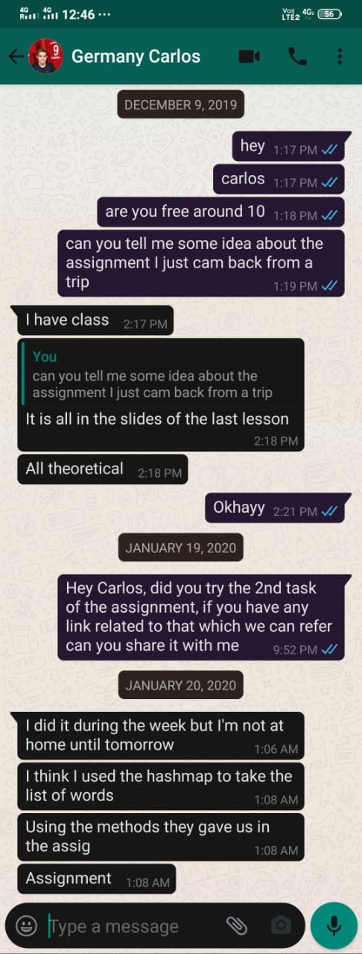

*Figure 3.1*

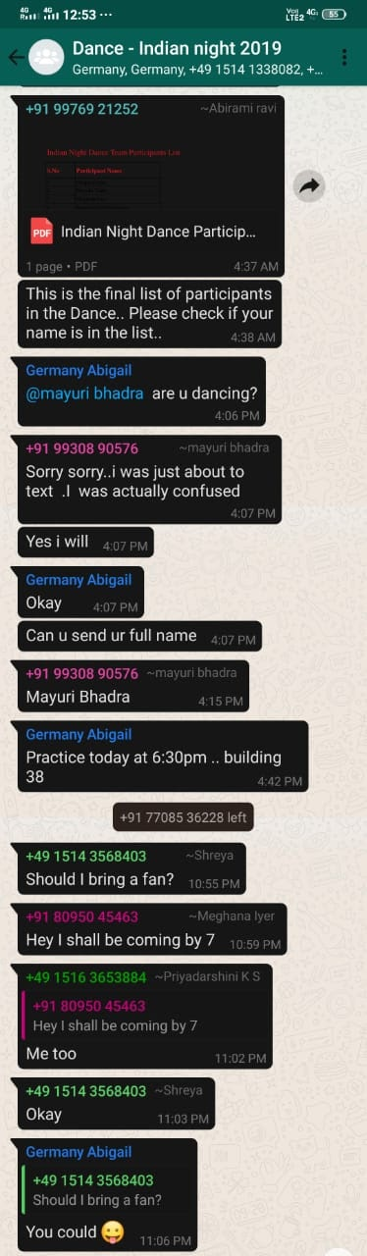

*Figure 3.2*



*Figure 3.3*

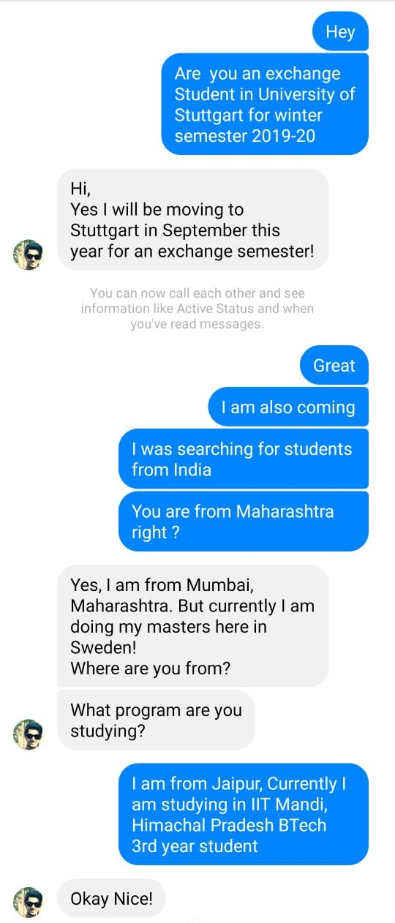

*Figure 3.4*

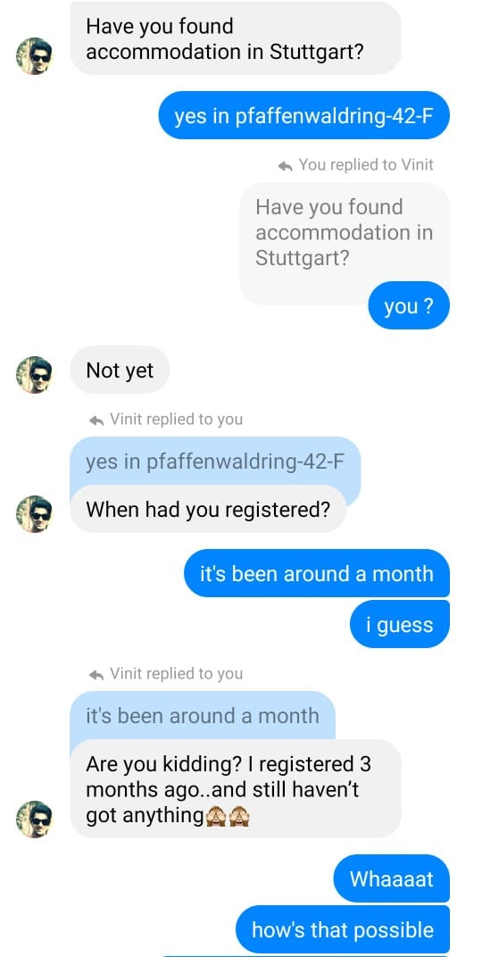

*Figure 3.5*



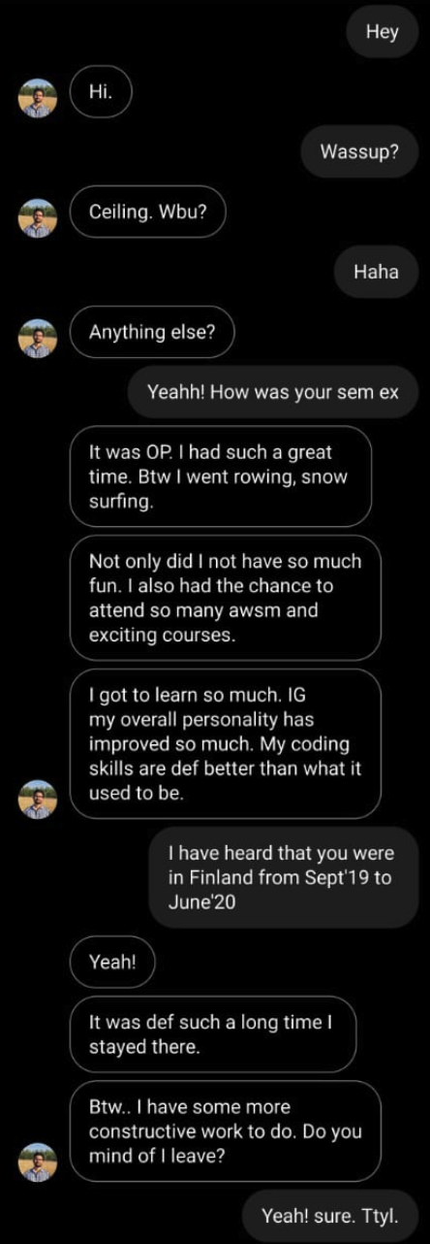

*Figure 3.6*

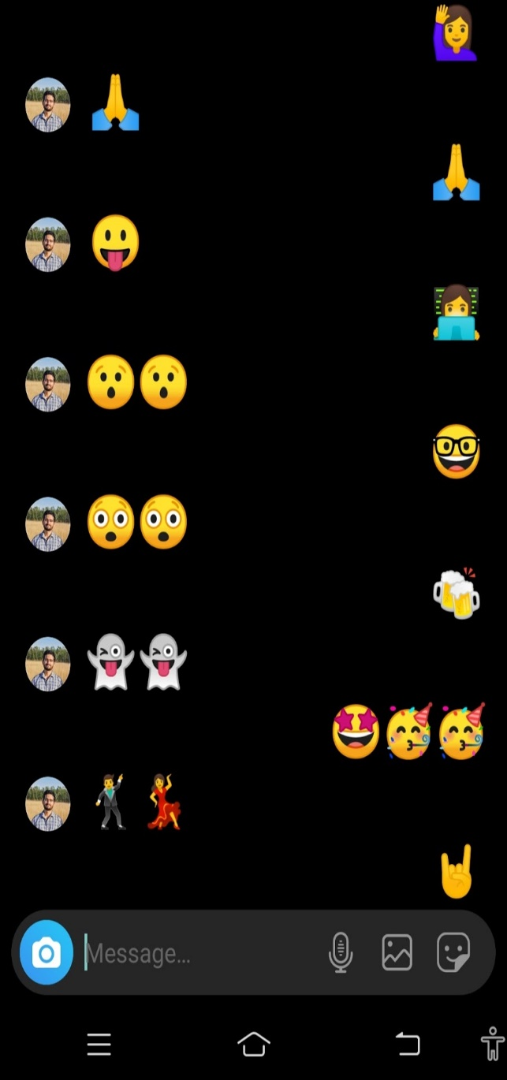

*Figure 3.7 (a)*

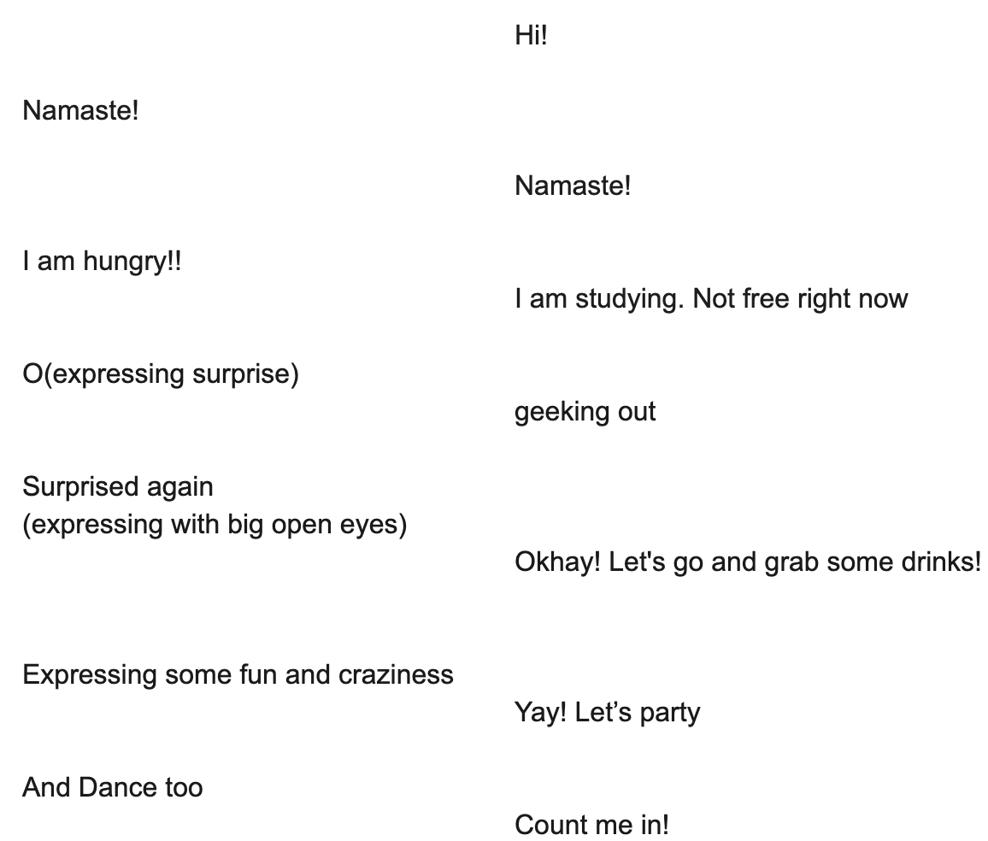

*Figure 3.7 (b)*

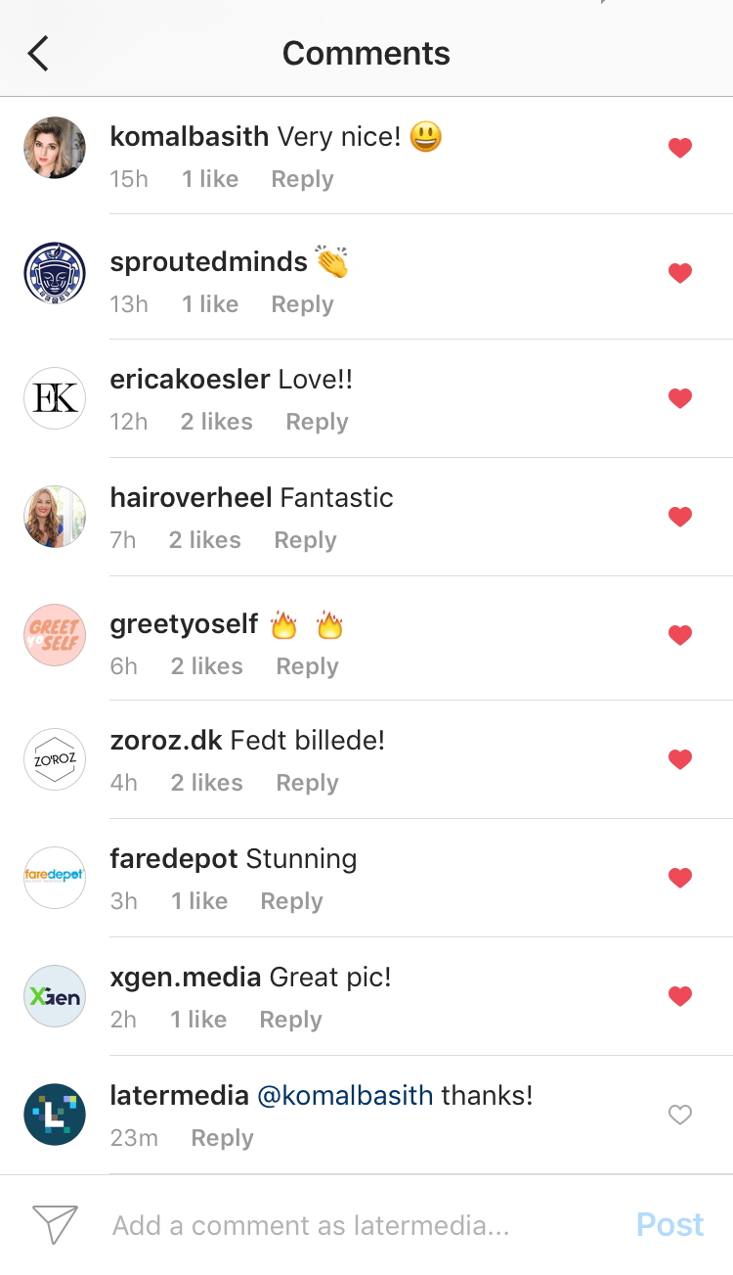

*Figure 3.8*

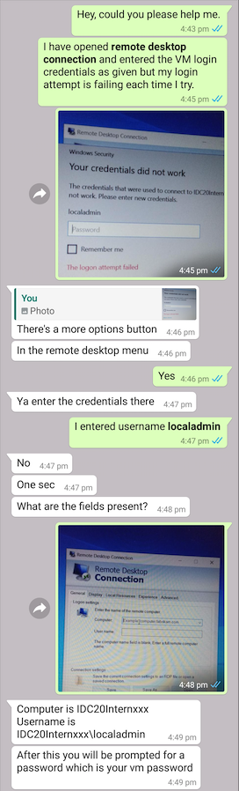

*Figure 3.9*

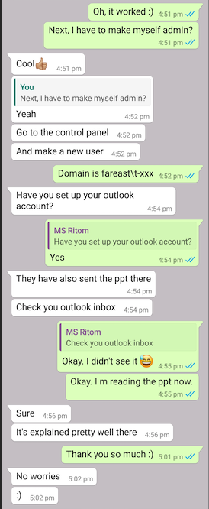

*Figure 3.10*

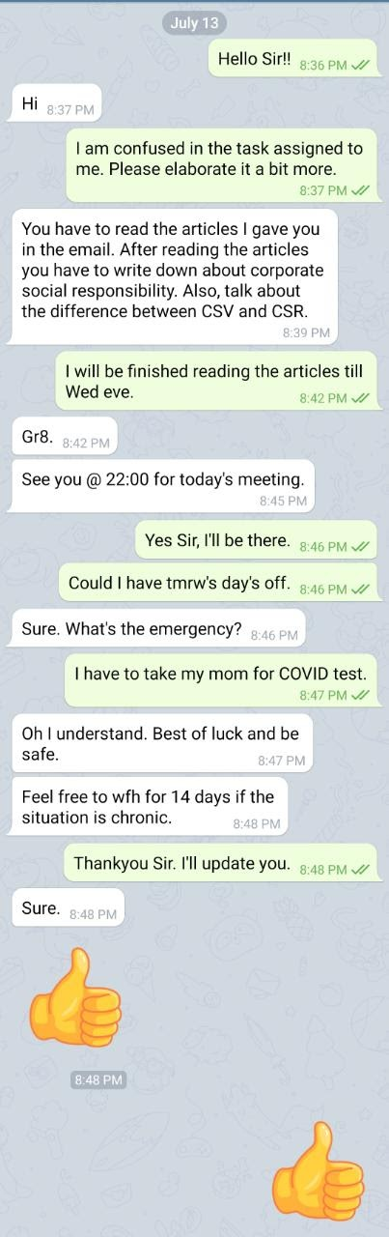

*Figure 3.11*

3.2 Areas of Analysis

Broadly classified in below mentioned subsections, we analyse how the English language is undergoing transformation by these social platforms, by the means of communication over the Internet. Language is constantly evolving. Social media is not only having an effect on the way we use English in day-to-day life but also the way we communicate.

3.2.1 Expression of Emotions

In the literature, authors or poets used to write or compose their work with a lot more words to express a feeling or emotion but now it can simply be done just by using emoticons, also discussed in previous chapters. People can express themselves better with pictorial representation (emojis here). *WhatsApp*, *Instagram* and *Messenger* are made for day-to-day chats; hence they are much more informal than the platforms discussed chapter 2. The emoticons used here are much more fun, quirky and even irrational sometimes. In ***figure 3.5*** the monkey emoji [🙈](https://emojipedia.org/see-no-evil-monkey/#:~:text=Depicted%20as%20the%20brown%20%F0%9F%90%B5,or%20figure%20for%20willful%20ignorance.) is used as a way of saying “I don’t want to see this”. It may also be used to express shyness, hiding oneself or it may be used just meaninglessly, for fun. ***Figure 3.7 (a)*** has nothing except emojis. ***Figure 3.7 (b)*** converts the emoticons into their text representation. Both the chats imply the same but (a) is much more fun and interesting. In ***figure 3.8,*** 🔥 fire emoji is used to express that the posted picture is amazing or hot, depending on the picture.

**3.2.2 Individuality**

The Internet has not only given rise to new words and emojis but a number of contexts for the same word. A word/emoji may have different meaning for different individuals. The conversation in ***figure 3.7 (a)*** converted to text looks like ***figure 3.7 (b)*** but the conversion will not be same for everyone.The 👻 ghost emoji can be used when someone is not feeling like themselves, they are feeling inconsequential or invisible or content related to the scary and supernatural, especially around Halloween. Thanks to its playful look, the emoji can also convey that someone or something is fun, goofy, wild, weird, or downright crazy. It can have a lot of meanings but for both the individuals here it was expressing fun.

In *figure 3.11*, terms like CSV and CSR are used. Here CSV is “Creating shared value” and CSR is “Corporate social responsibility” as both the individuals belong to the corporate world and work in management field. If it would have been a computer science person, CSV would be at first glance understood as “.csv” file extension. In *figure 3.9* and *figure 3.10,* VM stands for “virtual machine” and it is clearly understood by the intern and the mentor because of their software background. For a normal person, VM may mean “very much” or nothing. Similarly, “outlook” means email service here, whereas a person who does not know about it will understand it as “a person’s point of view”. “Account” means a bank account for people who are not familiar with technology whereas it is easily understood as “email account” by others. “Domain” means “an area of territory controlled by a particular rule” whereas in the software world, it is “a distinct subset of the Internet under control of a particular organisation”.

3.2.3 Omission of sentences and word decrement

In ***figure 3.1*** the student has written “assig” as now if he would have written “assign”, “assgn” or “assignm” all things would be inferred same by the other individual on chat, even though in proper English those words don’t even make sense. In ***figure 3.2*** during the group chat people have used:

‘u’ for ‘you’

‘ur’ for ‘your’

In *figure 3.3*, instead of writing “I agree” the person on the chat used “+1” and the meaning incurred from that is also the same. So here in layman terms maths is added to English. In *figure 3.6:*

“Wbu” was used instead of “What about you”

“sem ex” for “semester exchange”

“def” for definitely

“Btw” for by the way

“Ttyl” for talk to you later

The *figure 3.8* is comments section on Instagram. This screenshot has people coming up with one-word communication which also suggests the omission of long sentences to communicate. In *figure 3.9* and *3.10*:

“ppt” for presentation

“sec” for second

:) for smile

*Figure 3.11* suggests using numbers and symbols:

“Gr8” for Great

 “@“ for “at” while referencing time.

“tmrw” for tomorrow

“wfh” for work from home

“admin” for administrator

It is quite common for people to not care about correct grammar and spellings while messaging. A lot of people find it easier to not use correct spelling, punctuation and grammar when typing, because it’s a bit more efficient when they can be understood anyway.

3.2.4 Social groups

Face-to face interaction has decreased among the people but it has become easier to communicate with a greater number of people at the same time because of the social media platforms. As an example, here the documents which were shared in the *figure 3.2* can be distributed among all the individuals of the group so the time and efforts are also reduced. For many introverts who may not be able to speak openly about their views can now express in their words. The social group talks and chat groups both have their own importance as now the family members in different parts of the world can communicate and express their views on group chats or group video calls and can be more connected and aware than before.

Conclusion

Words that we commonly use today when talking about the Internet had a different meaning once upon a time. “Wireless”, for example, was used in 1950s to talk about radio. Likewise, “social networking” often meant the face-to-face kind; it didn’t conjure images of *Facebook* statuses and tweets. “Spam” usually now conjures up images of emails saying you’ve won million-dollar lottery, instead of canned stuff in the grocery store. The Internet is also now a breeding ground for new words – ones that have been tweaked or combined to become something new altogether. *Leetspeak,* for example uses numbers for l3tt3rs in some of its words. “Google” is now a verb, but once upon a time, it was just the humble name of a search engine. *Twitter* has given an entirely new way of communicating. “Hashtags” allow peopl­e across the world to sound off on a particular topic and expand the content of their “tweets” while still remaining in the character limit. A few years ago, nobody had heard of the terms “unfriend”, “selfie”, “fleek” or “emoji” however these words have trickled down from social media into our day to day conversation. Some of these terms have even made it to the Oxford Dictionary, ones that include: YOLO , “selfie”, “craptacular” and “amazeballs”, not to mention the recent social media trend of identifying high-profile couples by combining their first names to form a blend word, for example: Brangelina (Brad Pitt and Angelina Jolie) and Deepveer (Deepika Padukone and Ranveer Singh).

After analysing conversations on various media *- Slack, LinkedIn, Discord, WhatsApp, Messenger, Instagram* and *Telegram*, one can safely say that these networking platforms hosted on the Internet have had, and will continue to have a very heavy influence on the ever-evolving English language. Each day with the advent of new technology, with new content coming up every day on various platforms, new slangs, technical terms, and other kinds of words and phrases arise and attempt to transform and add to the very semantics, grammar and pragmatics of the English language, so much so that, an exclusive ‘tech’ or ‘gamer’ or any other community’s language appears so alienating to an outsider that it seemingly becomes a dialect with its own jargon built on the base of the original English.

In a nutshell, one of the most notable ways that the Internet has influenced the English language, is through appropriation of existing vocabulary. Words that had existing meanings, have now been given other meaning in an online context, which then spills over into verbal communication. The speed at which new vocabulary is introduced online, used, quickly over-used and then discarded is phenomenal.

Glossary

A list of some words and abbreviations that have been born/reborn on the Internet. Few of them have already been included in the preceding text.

1. Words
2. Antivaxxer

Now: “people against mandatory vaccines”

Origin: anti + vaccine

1. Avatar

Then: “descent of a god from the heavens into earthly form”

Now: “an icon or figure representing a particular person in a video game, internet forum, etc.”

1. Block

Then: “to be placed in front of something, such as a road or a path, so that people or things cannot pass through”

Now: “to prevent someone from contacting you on a social network or from viewing your profile”

1. Bois

Then: “wood (material), woodland”

Now: “distorted version of ‘boys’”

1. Bridezilla

Now: :a woman whose behaviour in planning the details of her wedding is regarded as obsessive or intolerably demanding”

Origin: bride + Godzilla

1. Bump

Then: “to encounter something that is an obstacle for hindrance”

Now: “to move an online post or thread to the top of the reverse chronological list by adding a new comment or post to the thread”

1. Catfish

Then: “a freshwater or marine fish with whisker like barbels around the mouth, typically bottom-dwelling”

Now: “a person who sets up a false personal profile on a social networking site for fraudulent or deceptive purposes”

1. Cloud

Then: “a visible mass of particles of condensed vapor suspended in the atmosphere of a planet”

Now: “any of several parts of the internet that allow online processing and storage of documents and data as well as electronic access to software and other resources”

1. Crema

Now: “brownish, milky foam formed on top of fresh, hot, espresso”

1. Cupertino

Then: “California city”

Now: “auto-correct errors, it occurs when the computer thinks it knows what you’re trying to say better than you do”

1. Dab

Then: “a small amount of something”

Now: “dance move believed to have originated in the Atlanta, Georgia rap scene, and in addition to that, dabbin’ is being used as a generalised term, to say that someone is elf-assured”

1. Dark Web

Now: “scary part of internet which is intentionally hidden from search engines from a special web server”

1. Derp

Now: “meaningless or stupid, or to comment on a foolish action”

Origin: a character in a comedy film

1. Ear tickler

Now: “someone who pleases other people with paying them a lot of compliments. It may also include nice behaviour, we well as music that is joyful to listen to”

1. Firehose

Then: “a large-diameter hose used in extinguishing fires”

Now: “a very large stream of data”

1. Footprint

Then: “a track or mark left by a foot or shoe”

Now: “a unique set of characteristics, actions etc. that leave a trace and serve as a means of identification”

1. Follow

Then: “to go or come after or behind someone or something; to pursue in an effort to overtake”

Now: “to subscribe to someone’s’ update on social media”

1. Friend

Then: “one attached to another by affection or esteem”

Now: “to add a person to one’s list of contacts on a social-networking website”

1. Geek

Then: “a crazy person”

Now: “a socially awkward and tech-savvy person”

1. GIF

Now: “a lossless format for image files that supports both animated and static images”

Origin: the word was created by someone

1. Handle

Then: “a part of something that is designed to be held by your hand”

Now: “your screen name, the name you go by on the internet”

1. Hashtag

Then: “pound sign”

Now: “used in Twitter to highlight a topic”

1. Instagrammer

Now: “someone who creates content in Instagram”

Origin: Instagram

1. Karen

Now: “a pejorative term used in the United States and other English-speaking countries for a woman perceived to be entitled or demanding beyond the scope of what is considered appropriate or necessary. A common stereotype is that of a racist white woman who uses her privilege to demand her own way at the expense of others”

Origin: Karen, an American name for a woman

1. Like

Then: “to be suitable or agreeable to”

Now: “to indicate one’s enjoyment or, agreement with, or interest in website content, especially in social media”

1. Lookbook

Now: “sets of photographs to promote collections, by fashion designers”

1. Manspreading

Now: “phenomenon where a man who sits with his legs wide apart, especially when sitting in public transport. He leaves no space for others to sit next to him and he is simply an unpleasant sight”

1. Meme

Then: “an idea, behaviour, style, or usage that spreads from person to person within a culture”

Now: “a cultural item in form of an image, video, phrase etc. that is spread via internet and often altered in a creative or humorous way”

1. Mic drop

Now: “act of intentionally dropping mic after an impressive performance”

1. Noob

Now: “a person who is inexperienced in a particular sphere or activity, especially computing or the use of internet”

Origin: n00b came from “newbie”

1. Photobomb

Now: “spoil a photograph by unexpectedly appearing in the camera’s field of view as the picture is taken, typically as a prank or practical joke”

1. Ping

Then: “a sharp sound like that of a striking bullet”

Now: “a brief electronic message, as a text message”

1. Pride

Then: “confidence and self-respect”

Now: “a parade in honour of LGBTQ community”

1. Princess syndrome

Now: “to describe a condition of narcissism, egocentrism and materialism in someone, or ‘princess’ behaviour”

1. Profile

Then: “a representation of something in outline; a concise biographical sketch”

Now: “the personal details, images, user statistics, social-media timeline etc. that an individual created and associates with a username or online account”

1. Sandbox

Then: “a low box filled with sand that children can play in”

Now: “an environment in which software developers or editors can create and test new content, separate from other content in the project”

1. Selfie

Now: “a photograph that one has taken of oneself, typically with a smartphone or webcam and uploaded to social media website”

Origin: self-portrait photography

1. Sext

Now: “send sexually photographs or messages via mobile phone”

Origin: sex + text

1. Swipe

Then: “a criticism or insult that is directed towards a particular person or group; a swinging movement of a person’s hand, an animal’s paw, etc”

Now: “to move the fingers across a touchscreen”

1. Tablet

Then: “something you take when you are sick”

Now: “a general-purpose computer contained in a touchscreen panel”

1. Tag

Then: “to supply with an identifying marker or price; to attach as an addition”

Now: “to link someone else’s profile in a social media post, commonly a photo or status update”

1. Timeline

Then: a table listing important events for successive years within a particular historical period”

Now: “a collection of online posts or updates associated with a specific social-media account, in reverse chronological order”

1. Troll

Then: “a dwarf or giant in Scandinavian folklore inhabiting caves or hills”

Now: “a person who shows discord on the internet by starting arguments or upsetting people”

1. Tweet

Then: “a chirping note”

Now: “a very short message posted on the Twitter website”

1. Twerk

Now: “dance to popular music in a sexually provocative manner involving thrusting hip movements and a low, squatting stance”

Origin: “work” to “werk”, since dancers are often told to “work it”. The extra t may mean “twitch” or “twist”

1. Unplug

Then: “to disconnect something, such as a lamp or television from an electrical source or another device by removing its plug”

Now: “to refrain from using digital or electronic devices for a period of time”

1. Viral

Then: “of, relating to, or caused by a virus”

Now: “becoming very popular by circulating quickly from person to person, especially through the internet”

1. Weak sauce

Now: “something that is not good quality or does not perform well”

Origin: the expression originates from mild hot sauce at Taco Bell. It does not meet people’s expectations for hot sauce

1. Woot

Now: “used to express elation, enthusiasm, or triumph”

Origin: w00t is popular among gamers

1. YouTuber

Now: “someone who creates content on YouTube”

Origin: YouTube

1. Abbreviations and short-forms
2. AITA – am I the asshole
3. AF – As fuck
4. AFAIK – As far as I know
5. AFAIC – As far as I am concerned
6. AMA – Ask me anything
7. ASAP – As soon as possible
8. ASL – Age sex location
9. BAE – Before anyone else
10. BFF – Best friends forever
11. BRB – Be right back
12. BTW – By the way
13. BUMP – Bring up my post
14. B@U – Back at you
15. CSL – Can’t stop laughing
16. DM – Direct message
17. DIY – Do it yourself
18. Esp - Especially
19. FOMO – Fear of missing out
20. FYI – For your information
21. FB - Facebook
22. G2G – Good to go
23. GL – Good Luck
24. Gr8 – Great
25. IDC – I don’t care
26. IDK – I don’t know
27. ILY – I love you
28. IMU – I miss you
29. IMO – In my opinion
30. IMHO – In my humble opinion
31. IRL – In real life
32. JK – Just kidding
33. J4F – Just for fun
34. JSYK – Just so you know
35. LMAO – Laughing my ass off
36. LMK – Let me know
37. LOL – Laugh out loud
38. NGL – Not gonna lie
39. NBD – No big deal
40. NSFW – Not safe for work
41. NSFL – Not safe for life
42. OMG – Oh my god
43. PFA – Please find attached
44. PM – Personal message
45. QQ – crying
46. ROFL – Roll on the floor laughing
47. RT – Retweet
48. SJW – Social justice warrior
49. Srsly – Seriously
50. STFU – Shut the fuck up
51. TBT – Throwback Thursday
52. TIL – Today I learned
53. TL;DR – Too long didn’t Read
54. TBH – To be honest
55. TTYL – Talk to you later
56. WFH – Work from home
57. W8 - Wait
58. YGTR – You got that right
59. YOLO – You only live once
60. Zzz - sleeping

References

[1] https://www.conferencecallsunlimited.com/history-of-communication-technology/

[2] <https://www.sutori.com/story/communication-before-and-after-technology--NcLh2RuqX8Ny2bMRzEGhGjtg>

[3] https://time.com/5629246/because-internet-book-review/

[4] <https://www.researchgate.net/publication/323052712_Evolution_of_> english_in_the_internet_age

[5] <https://www.usg.edu/galileo/skills/unit07/internet07_02.phtml>

[6] <https://interestingengineering.com/a-chronological-history-of-social-media>

[7] <https://blog.hootsuite.com/history-social-media/>

[8] <https://www.socialmediatoday.com/news/the-history-of-social-media-infographic-1/522285/>

[9] <https://www.bustle.com/articles/155379-are-there-internet-dialects-heres-how-the-world-wide-web-has-changed-how-we-communicate>

[10] <https://www.oxford-royale.com/articles/4-ways-internet-english-language/#aId=5c8845e8-6735-4878-94b4-904390fabd0d>

[11] <https://www.lifewire.com/how-to-use-pinterest-3486578>

[12] <https://en.wikipedia.org/wiki/Discord_(software)>

[13] https://simple.wikipedia.org/wiki/WhatsApp

[14] https://en.wikipedia.org/wiki/LinkedIn

[15] https://en.wikipedia.org/wiki/Slack_(software)

[16] https://royal.pingdom.com/irc-is-dead-long-live-irc/#:~:text=IRC%20(Internet%20Relay%20Chat)%20has,a%20dramatic%20downturn%20in%20usage.

[17] https://www.theatlantic.com/technology/archive/2019/03/how-discord-went-mainstream-influencers/584671/

[18] https://later.com/blog/like-instagram-comments/

[19] <https://smallbusiness.yahoo.com/advisor/resource-center/internet-changed-english-language-160050172/>

[20] <https://www.stuff.co.nz/technology/digital-living/73137703/24-words-that-have-changed-since-the-internet>

[21] <https://www.theguardian.com/books/2013/apr/17/tom-chatfield-top-10-internet-neologisms>

[22] <https://www.hongkiat.com/blog/dictionary-words-from-internet/>

[23] <https://www.fluentu.com/blog/english/new-english-words/>

[24] <https://preply.com/en/blog/2020/05/07/the-most-used-internet-abbreviations-for-texting-and-tweeting/#scroll-to-heading-10>

[25] https://www.languageservicesdirect.co.uk/social-media-changing-english-language/